**Chapter 10: Operational Amplifiers**

Table of Contents

10.1. Introduction 2

10.4 Op-Amp Basics 4

Virtual Ground 5

10.5 Practical Op-Amp Circuits 6

Inverting Amplifier 6

Non-Inverting Amplifier 6

Summing Amplifier 7

## 10.1. Introduction

An operational amplifier, or op-amp, is a high-gain amplifier. The basic diagram looks like this:

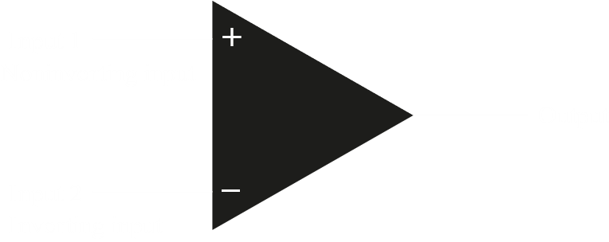

An operational amplifier has two modes of input, single ended and double ended. With single ended input, an alternating input is given to one of the inputs while the other input is connected to ground. If the input is given to the non-inverting end, the output is just an amplified version of the input. If the input is given to the inverting end, then the output is amplified and inverted.

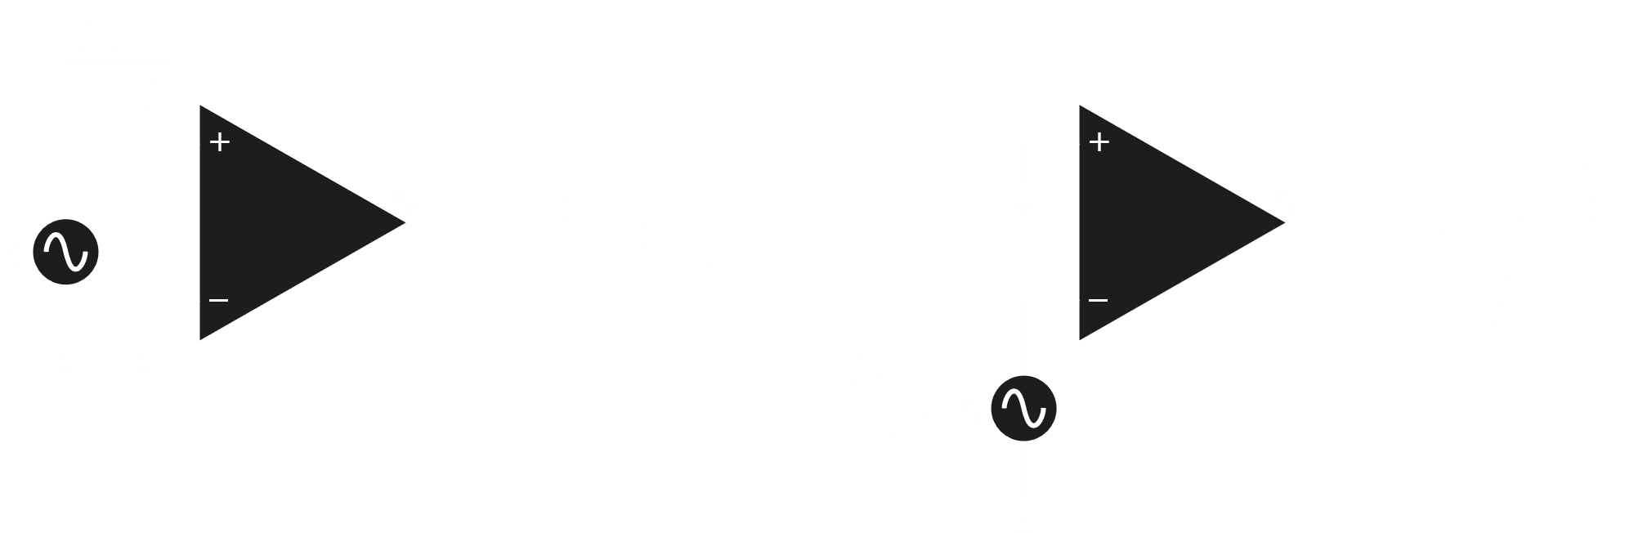

Double-ended, or differential input, is when an input single is applied to both the inverting and non-inverting inputs. If a single input is used and opposite ends are connected to the two inputs, we get an output that is amplified and is in-phase with the input signal. Keep in mind that there is no ground connection in this case. If instead, two separate inputs $V_{i_{1}}$ and $V_{i_{2}}$ are connected, the output is the difference between the inputs, $V_{i_{1}}-V_{i_{2}}$.

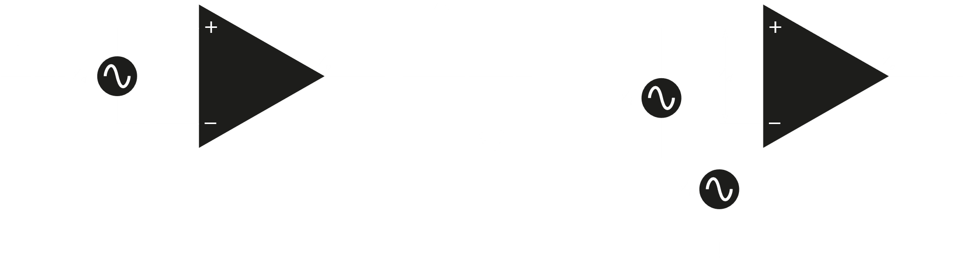

Typically, the amplification of an op-amp is of the order ${10}^{6}$, i.e. given an input signal in the $μV$ range, the signal would be converted to the $V$ range. The energy required for amplification comes from $V_{CC}$.

We can also connect the same end of the input signal to both of the inputs, as shown below. This is called common-mode operation.

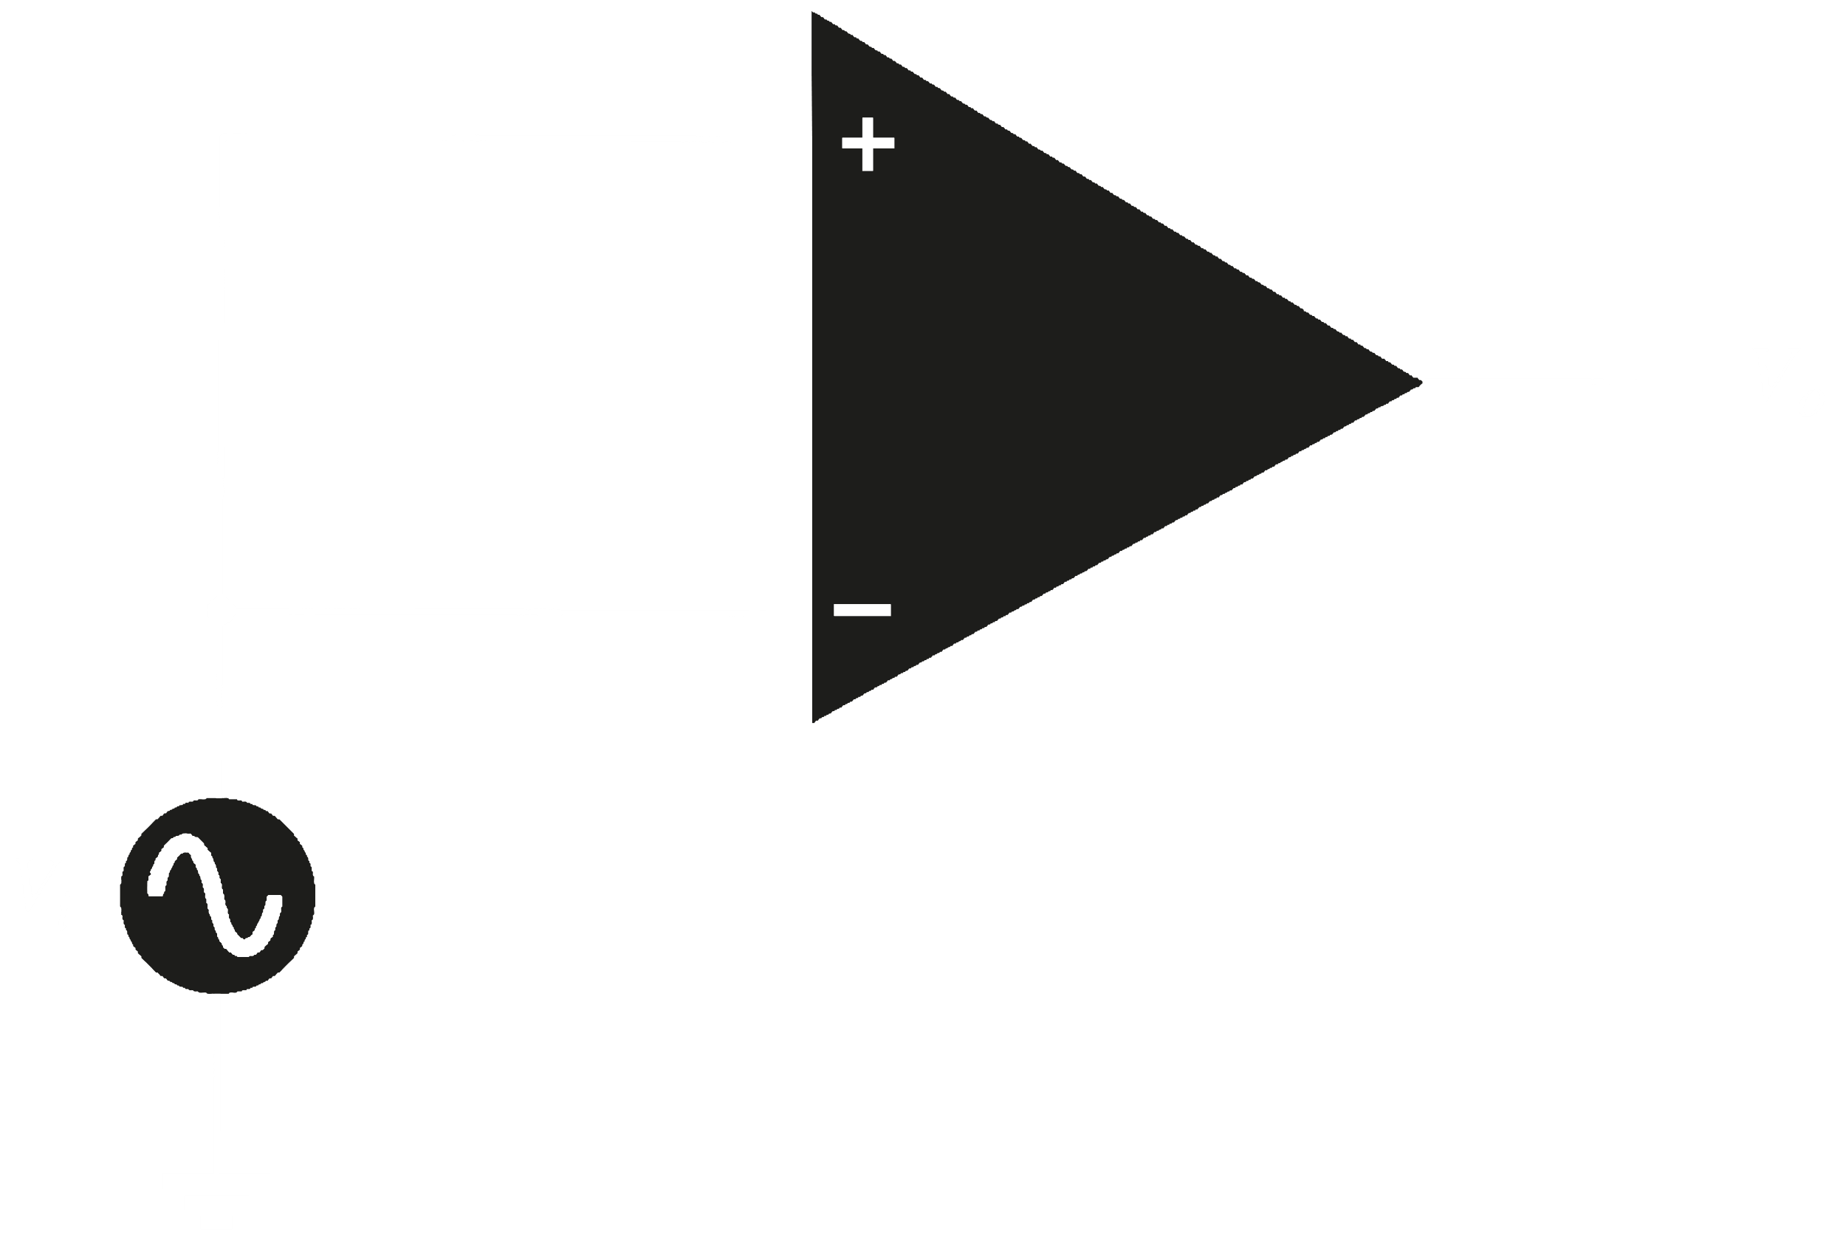

Ideally, this configuration should have the two inputs cancel each other out, giving a 0 output, but practically a small output is received. A major application of this configuration is in noise cancellation. When signals that are opposite to each other are applied to the two inputs, the result is a high level of amplification. However, a common signal will get almost cancelled out. Since noise is common to both inputs, it is cancelled out. This feature is called common-mode rejection.

## 10.4 Op-Amp Basics

The AC equivalent of an op-amp is shown below. The input voltage $V_{d}$ faces an input resistance $R_{i}$ that is typically very high. The output voltage $V_{o}$ is the result of the amplification $A_{d}$ times the input voltage, taken through an output impedance $R_{o}$, that is much lower than $R_{i}$.

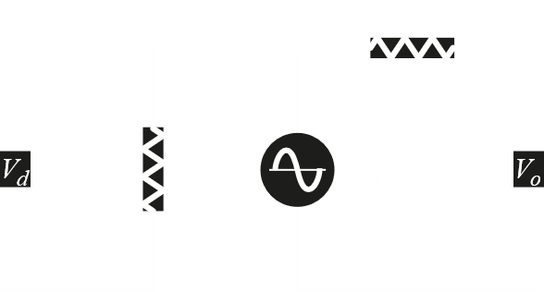

An ideal op-amp would have an infinite input impedance, zero output impedance and infinite voltage gain.

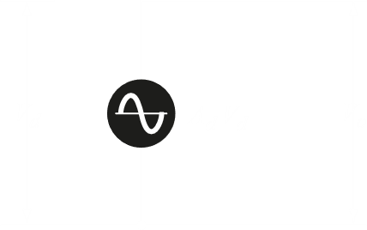

Everything we have seen so far was for open loop configurations. There is another configuration called the closed-loop configuration that takes a part of the output and puts it back into the input.

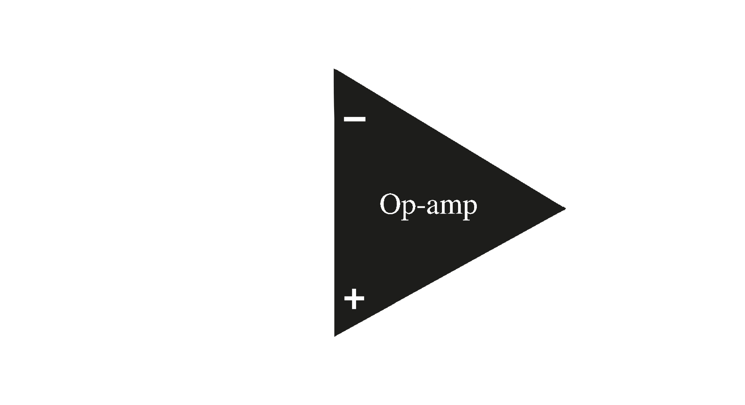

The input $V_{1}$ is connected to the inverting input of the op-amp, meaning the output $V_{o}$ is opposite in phase to the input. When the output is connected back to the input, the input thus becomes smaller. The gain of a closed loop configuration is thus much lower than that of an open loop configuration in this case.

The figure above is for a negative feedback. Here, $\frac{V_{o}}{V_{1}}=-\frac{R_{f}}{R_{1}}$. Thus, we can see that the amplification is purely dependant on the two resistors, $R_{f}$ and $R_{1}$. If $R_{f}=R_{1}$, $V_{o}=-V_{1}$, so there is no gain and the signal is simply inverted. This is called unity gain. If $R_{f}$ is some multiple of $R_{1}$, then we will get a gain of $-n$. This is called constant magnitude gain.

### Virtual Ground

For negative feedback, we know that $V_{o}=A×V_{i}$ (where $V_{i}$ is the difference between the voltages of the two inputs). If $V_{o}=10V$, and $A={10}^{6}$, then $V_{i}=v^{+}-v^{-}=10μV$. This value is so small, that it is almost negligible and $V_{i}≈0V$. The inverting and non-inverting terminals have been virtually shorted.

## 10.5 Practical Op-Amp Circuits

### Inverting Amplifier

The output is obtained by multiplying the input by a fixed or constant gain set by the input resistor $R_{1}$ and the feedback resistor $R_{f}$. The output is also inverted.

$$V_{0}=-\frac{R_{f}}{R_{1}}V_{1}$$

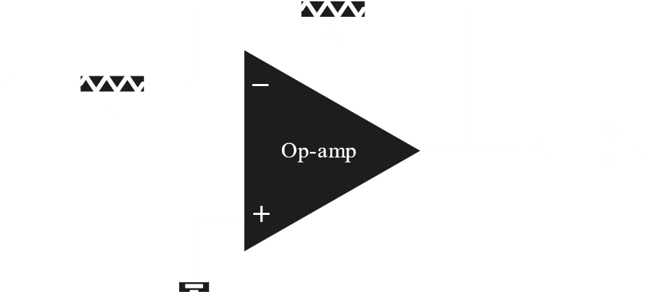

### Non-Inverting Amplifier

In this configuration, since $V_{i}≈0V$, $R_{1}$ is $V_{1}$. Thus, $V_{0}=\left(1+\frac{R_{f}}{R_{1}}\right)V_{1}$.

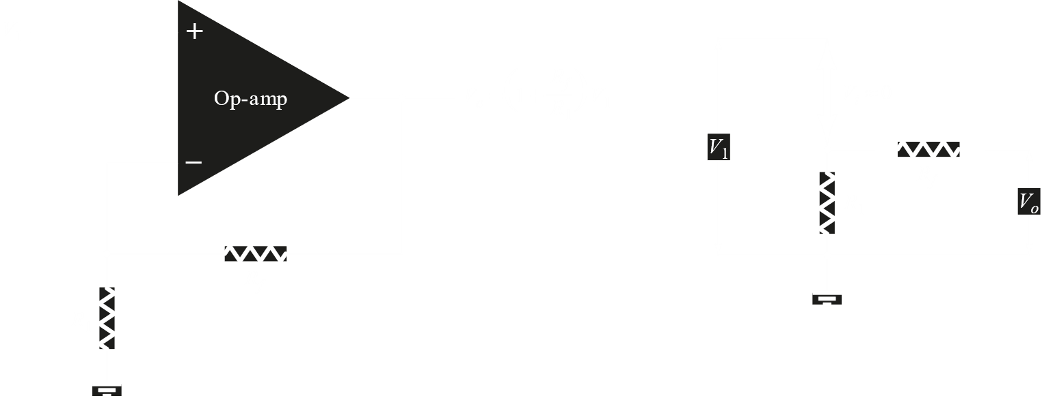

### Summing Amplifier

A summing amplifier is used to sum three voltages, each multiplied by a constant-gain factor. $V_{0}=-\left(\frac{R_{f}}{R_{1}}V_{1}+\frac{R_{f}}{R_{2}}V_{2}+\frac{R_{f}}{R_{3}}V_{3}\right)$

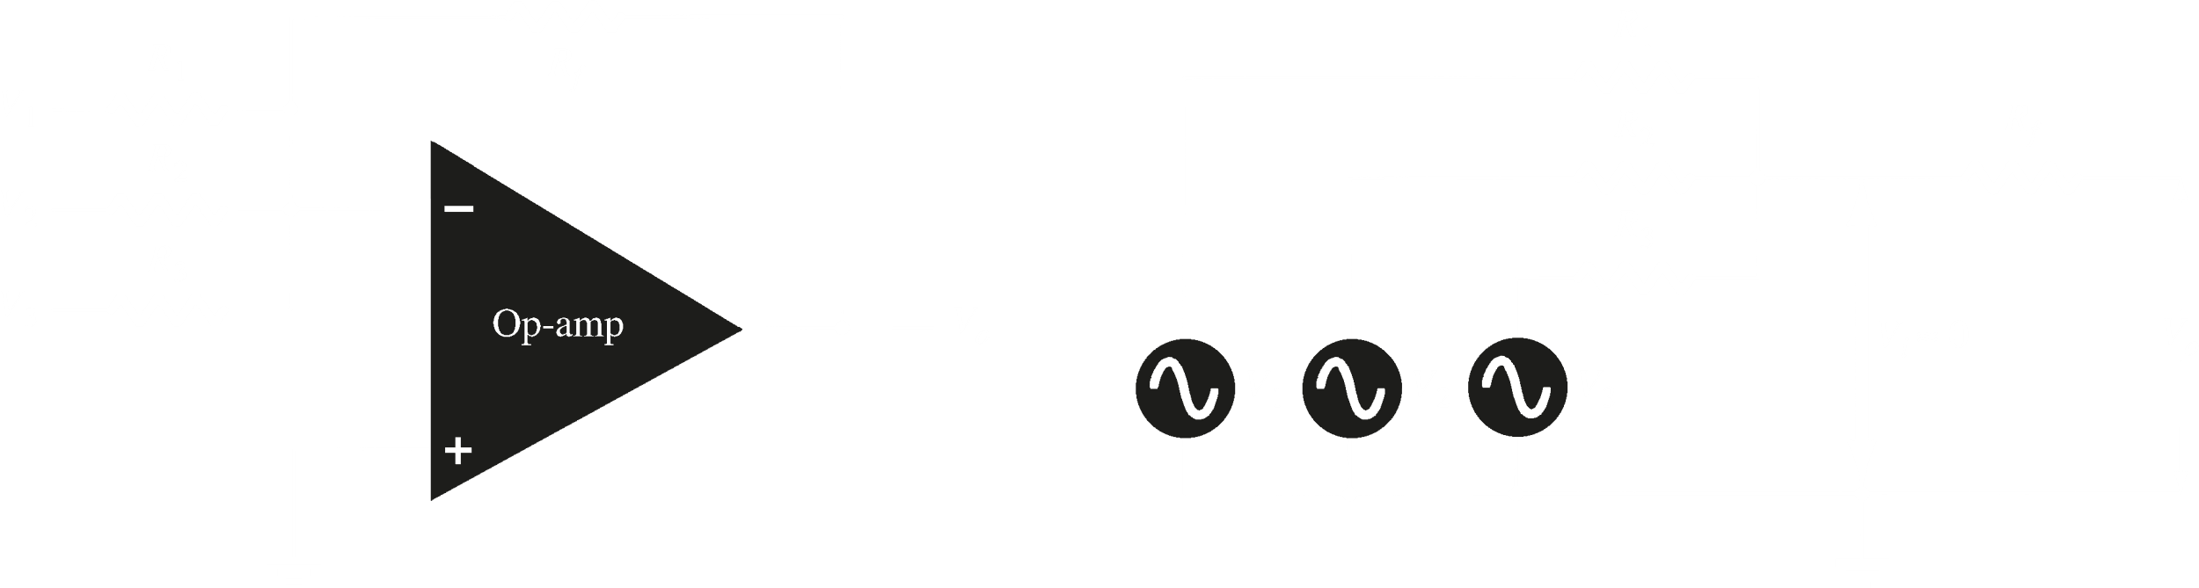

Op-Amps can also be used as integrators and differentiators.